**Over The Wire**

## Level 1 to Level 2

**Step 1: SSH Login**

**Password:** **ZjLjTmM6FvvyRnrb2rfNWOZOTa6ip5If**

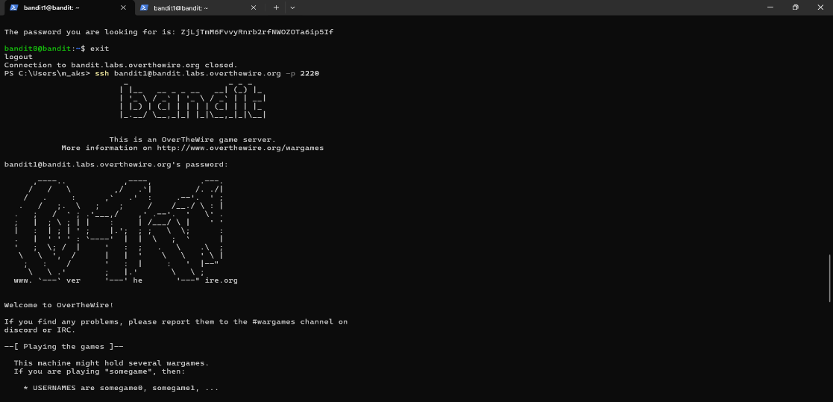

**Step 2: Find the hidden file ("-") (ls -alps)**

**Step 3: Read the hidden file (cat ./-)**

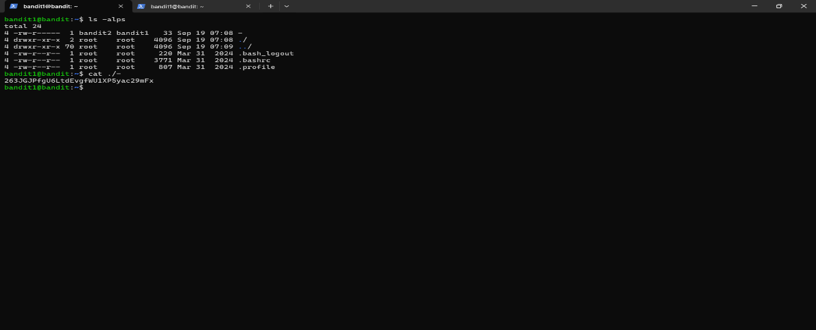

**Output:**

**Password:263JGJPfgU6LtdEvgfWU1XP5yac29mFx**